APPENDIX C

User Interface Mockups
These user interface designs were created based on the system requirements and follow the general style of iOS applications to ensure clarity and usability.
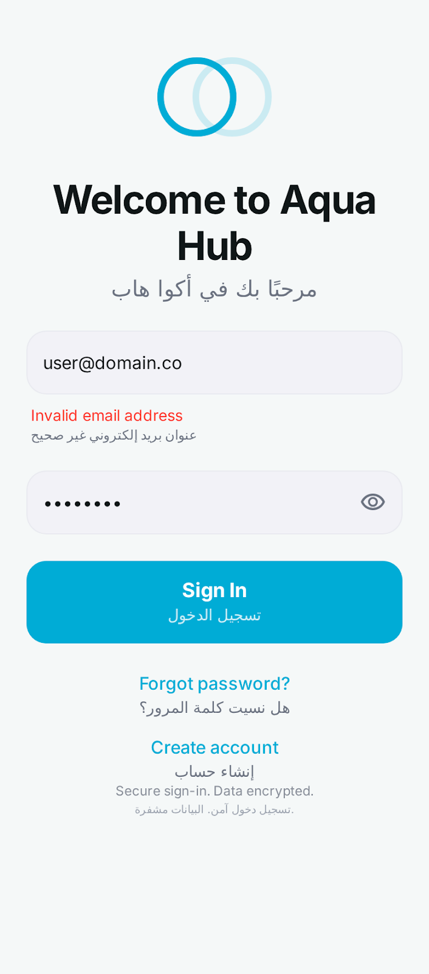

Figure C.1: Login Screen (User Authentication)

This screen allows users to securely sign in using their registered email and password.
It provides an option for password recovery and new user registration ensuring data security and accessibility.
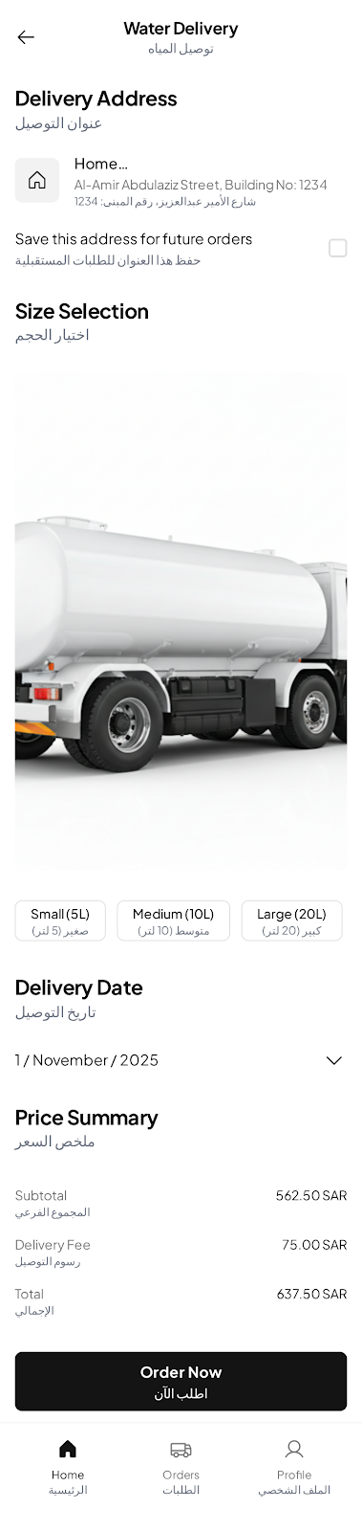

Figure C.2: Home Screen (Service Overview)
This screen displays the available Aqua Hub services such as Water Delivery Tank Cleaning and Maintenance. Users can navigate through the app using the bottom tab bar that includes Home Orders Payments and Profile sections.

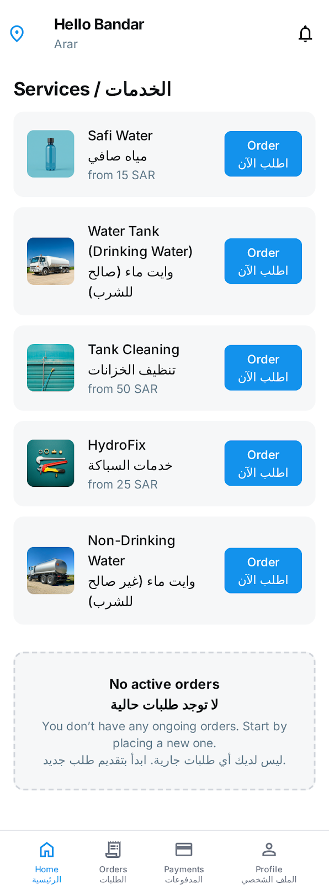

Figure C.3: Service Details (Order Placement)

This interface enables users to select a service specify quantity choose a delivery time and confirm an order. It presents key service details like price estimated delivery time and customer rating.
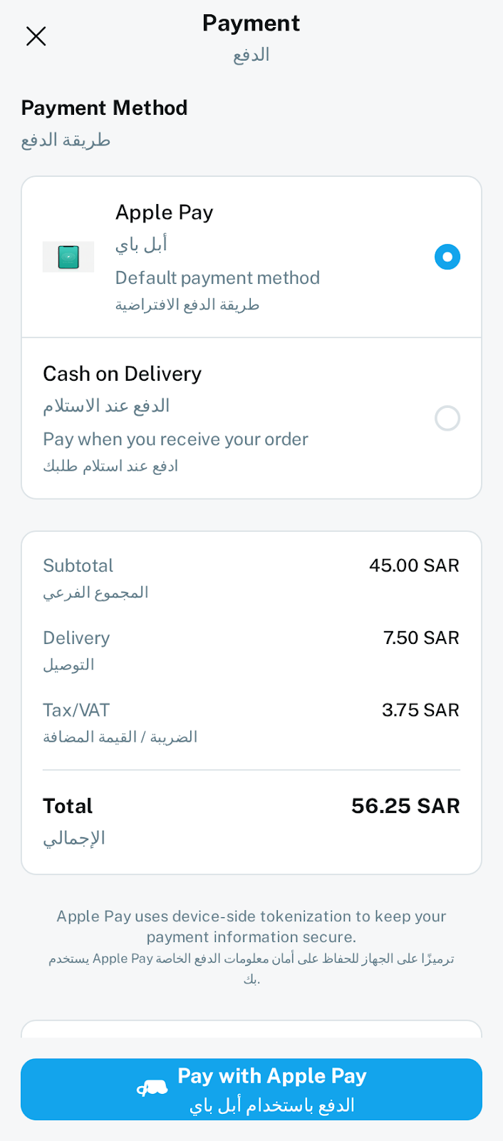

Figure C.4: Payment Screen (Apple Pay Integration)
This screen supports secure payment through Apple Pay or Cash on Delivery. It summarizes order costs and provides confirmation options with transaction security notes.
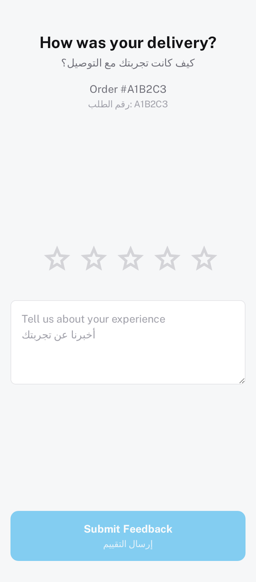

Figure C.5: Feedback Screen (Rate and Comment)
This screen allows users to rate the completed service and leave feedback comments. It helps Aqua Hub improve service quality and customer satisfaction monitoring.

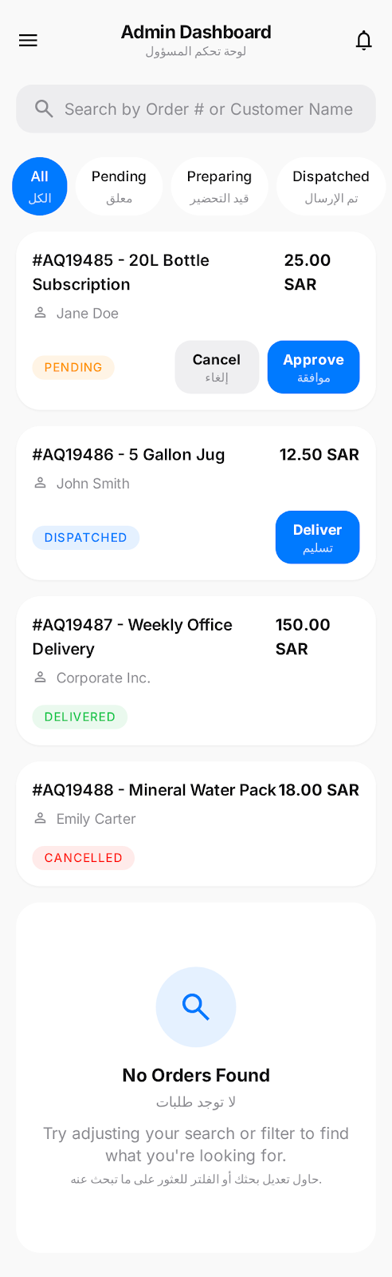

Figure C.6: Admin Dashboard (Manager Control Panel)
This interface provides administrators with a centralized dashboard to manage and track customer orders.
It includes a search bar for locating orders by number or customer name, and filter tabs that organize requests by status (All, Pending, Preparing, Dispatched, Delivered, Cancelled).
Each order card displays essential information — order code, service name, customer identity, price, and status — along with contextual actions such as Approve, Deliver, or Cancel.
The design ensures that administrators can quickly review operational activity, update order states, and maintain efficient workflow visibility within Aqua Hub’s management system.

Appendix C.5 – Service Option Selection Screens
This section presents the enhanced user interaction flow for the Aqua Hub mobile application, focusing on service customization within the same “Home – Services” interface.
The updated design introduces bottom-sheet modals that allow users to choose quantities, capacities, or service types without navigating away from the main screen.
Each bottom sheet appears with rounded top corners, a drag indicator, and a clear “Confirm Order” and “Cancel” action area. This maintains interface consistency and provides a fast, intuitive experience.

Figure C.5 (a) – Safi Water Option Selection
The user can select the preferred quantity: 1 bottle – 3 SAR, 6-pack – 15 SAR, or 12-pack (carton) – 25 SAR.

Figure C.5 (b) – Drinking Water Tank Selection
This modal allows the user to choose tank capacity: 5 000 L – 25 SAR, 10 000 L – 40 SAR, or 20 000 L – 70 SAR.

Figure C.5 (c) – Tank Cleaning Service Selection
The user specifies cleaning type and size: Ground Tank – 50 SAR, Roof Tank – 60 SAR, or Large Industrial Tank – 120 SAR.

Figure C.5 (d) – HydroFix Maintenance Selection
Options include: Leak Fix – 25 SAR, Pipe Installation – 40 SAR, and Full Inspection – 60 SAR.

Figure C.5 (e) – Non-Drinking Water Tank Selection
This screen presents more affordable capacities for non-potable use:
Small (5 000 L) – 15 SAR, Medium (10 000 L) – 25 SAR, Large (20 000 L) – 45 SAR, and Industrial (30 000 L) – 65 SAR.
Each modal preserves the Aqua Hub color palette (white cards, blue accent #00ACD6 – #008CFF gradient) and consistent typography.
Together, these designs demonstrate scalability of the service-ordering flow while maintaining a unified and user-friendly interface.
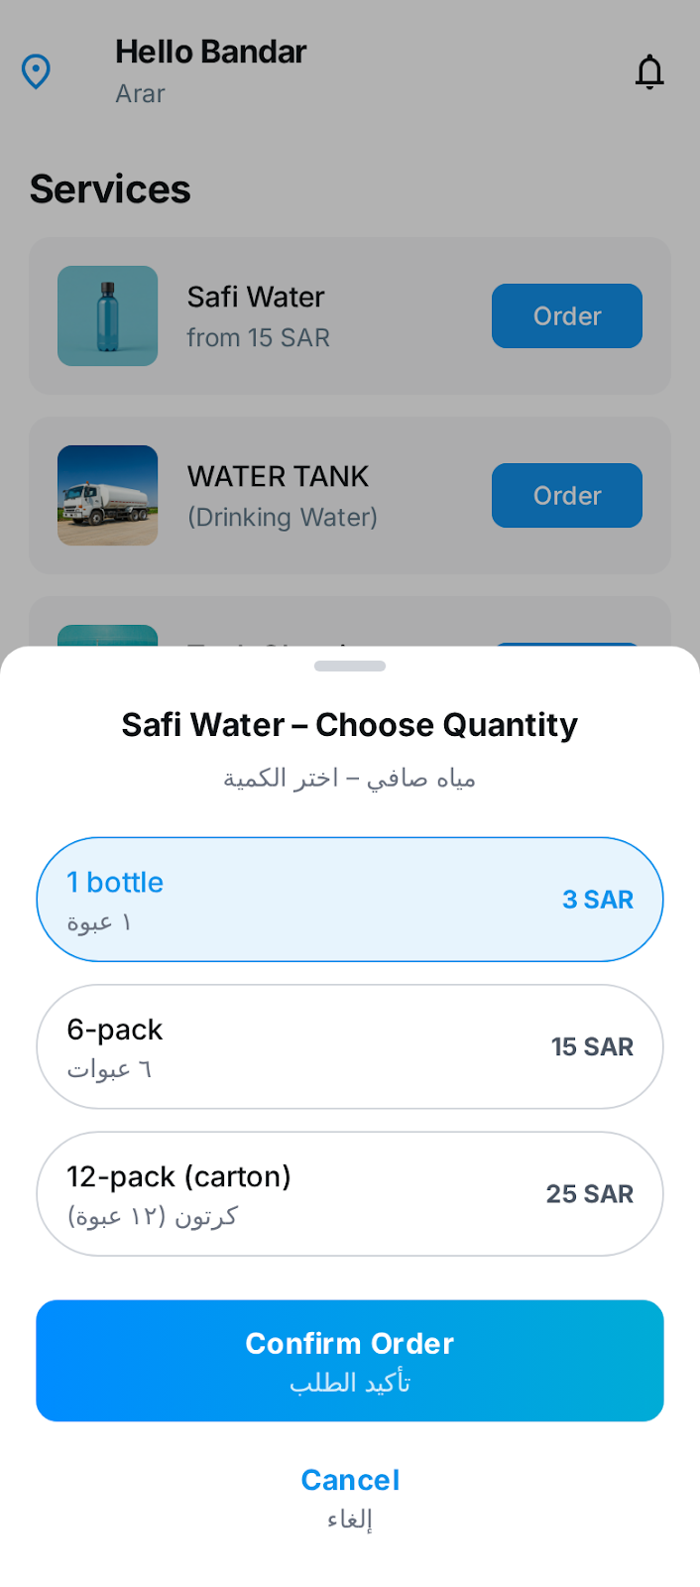
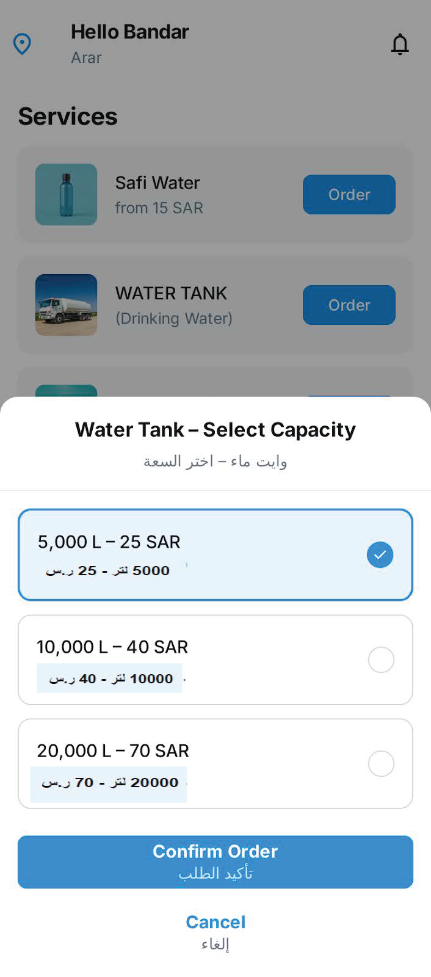

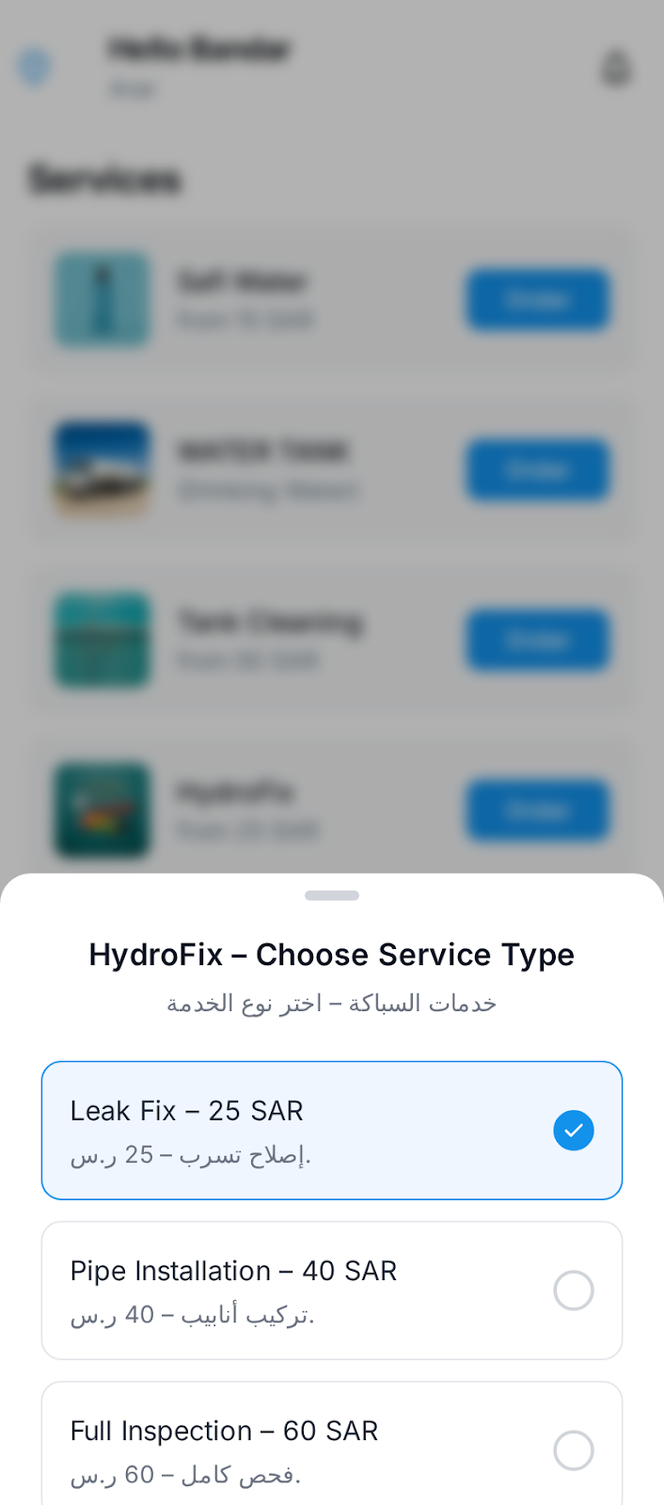
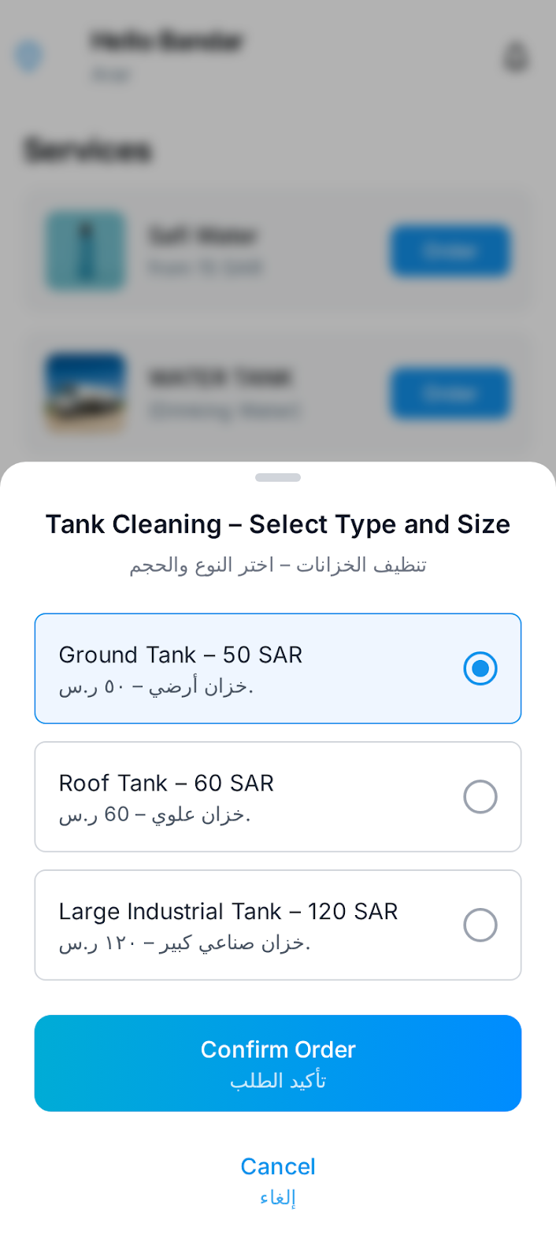

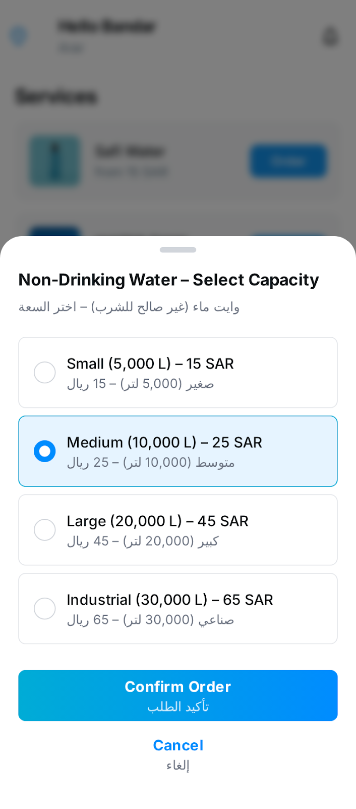

Conclusion
The mockups presented in this appendix illustrate a user centered design approach focusing on clarity consistency and usability. Although conceptual they demonstrate adherence to modern UI/UX principles for iOS applications. Such interface planning ensures intuitive navigation efficiency and enhanced user satisfaction.

References
Google. (2025). Stitch (Beta) – Design with AI. Retrieved from https://stitch.withgoogle.com

